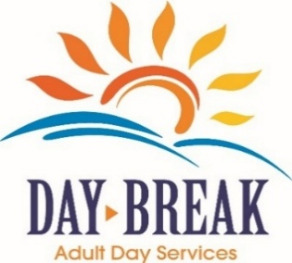


Join Us for Some Bingo!
Fun prizes, great company, light refreshments will be provided.

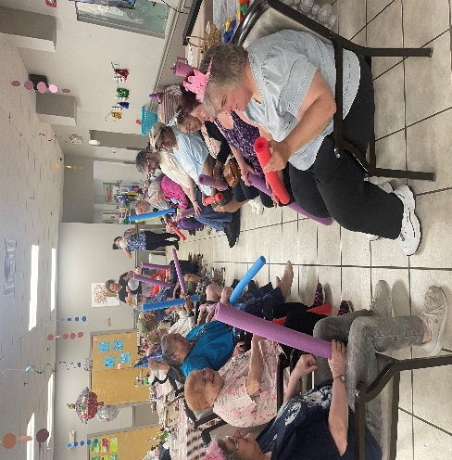

When: WEDNESDAY, JULY 15TH 2026
Time: 11AM-12PM
Location: CARTER LANE COMMUNITY ROOM

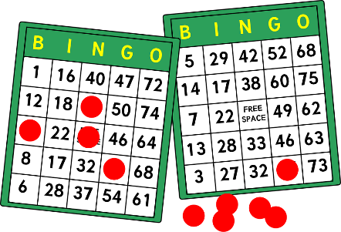

Daybreak enables our seniors to continue to enjoy an enriching and fulfilling lifestyle while living in their homes. Daybreak provides an extensive variety of services such as …..
- Handicap accessible transportation to/from home
- Breakfast, snacks, and hot nutritious lunches
- Exercise and physical activities
- Educational and Recreational games, entertainment, Daily Bingo
- Community Outings
- On Staff Nursing care including monthly evaluations and medication administration
- Personal care assistance including incontinent care, showering, shaving and feeding
- Holiday celebrations, themed weeks, and Birthday parties for clients
- Bilingual staff
- Alzheimer/Dementia program for clients who need it
We offer a FREE Trial to come and try out our program. Meals and transportation are included. For more information or to schedule a trial day please call Adipel Lopez, 860-747-4093.





